https://www.google.com/url?sa=i&url=https%3A%2F%2Fquizmanthon.com%2Felearn-goals-of-ai.php&psig=AOvVaw3G5QXMgrUulsK_2LHVOaaR&ust=1668862184775000&source=images&cd=vfe&ved=0CA0QjRxqFwoTCOjk8bfit_sCFQAAAAAdAAAAABAX

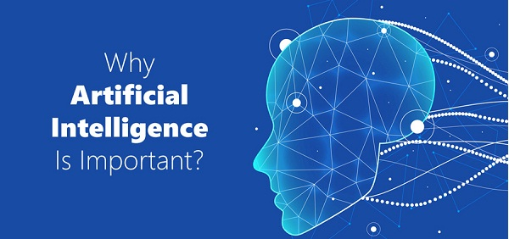

Geschiednis

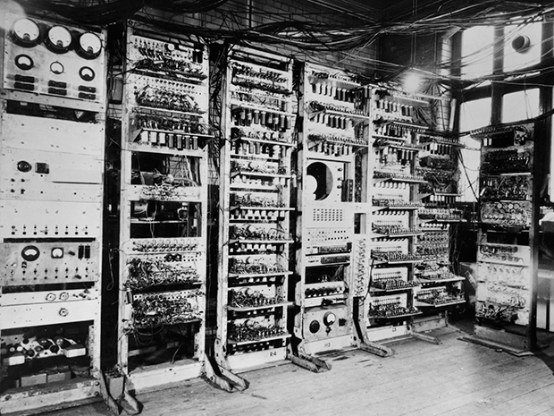

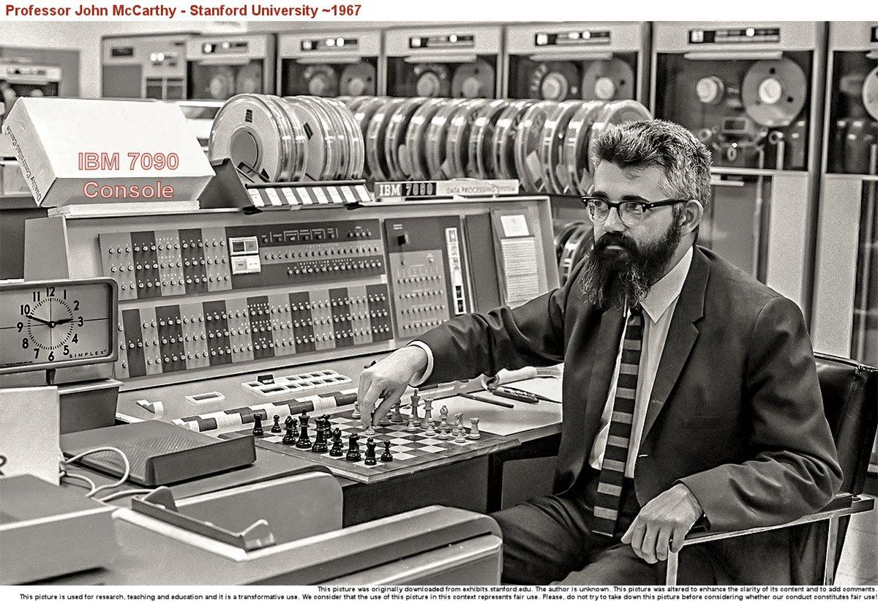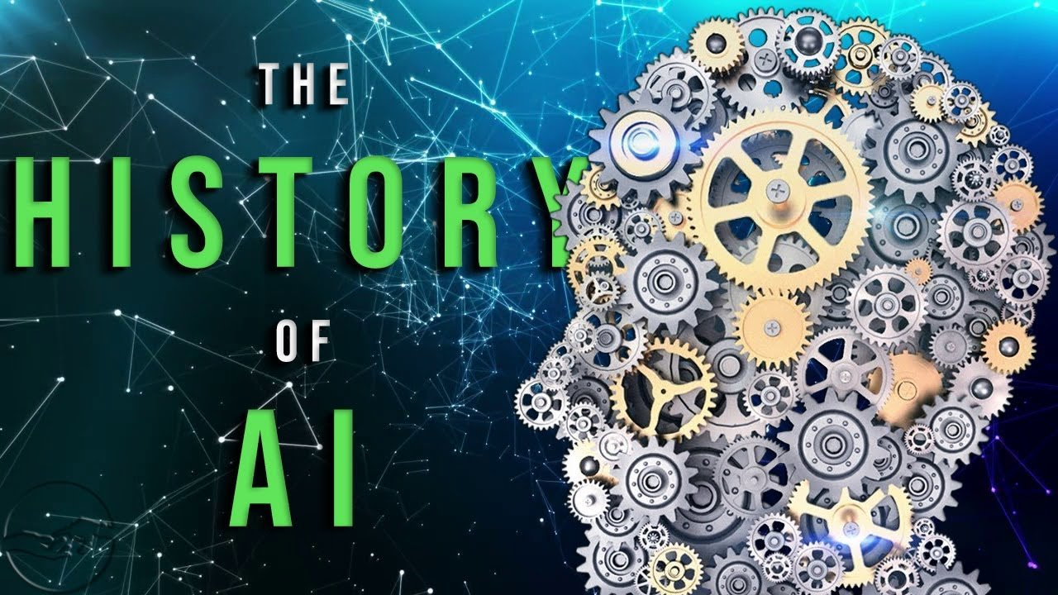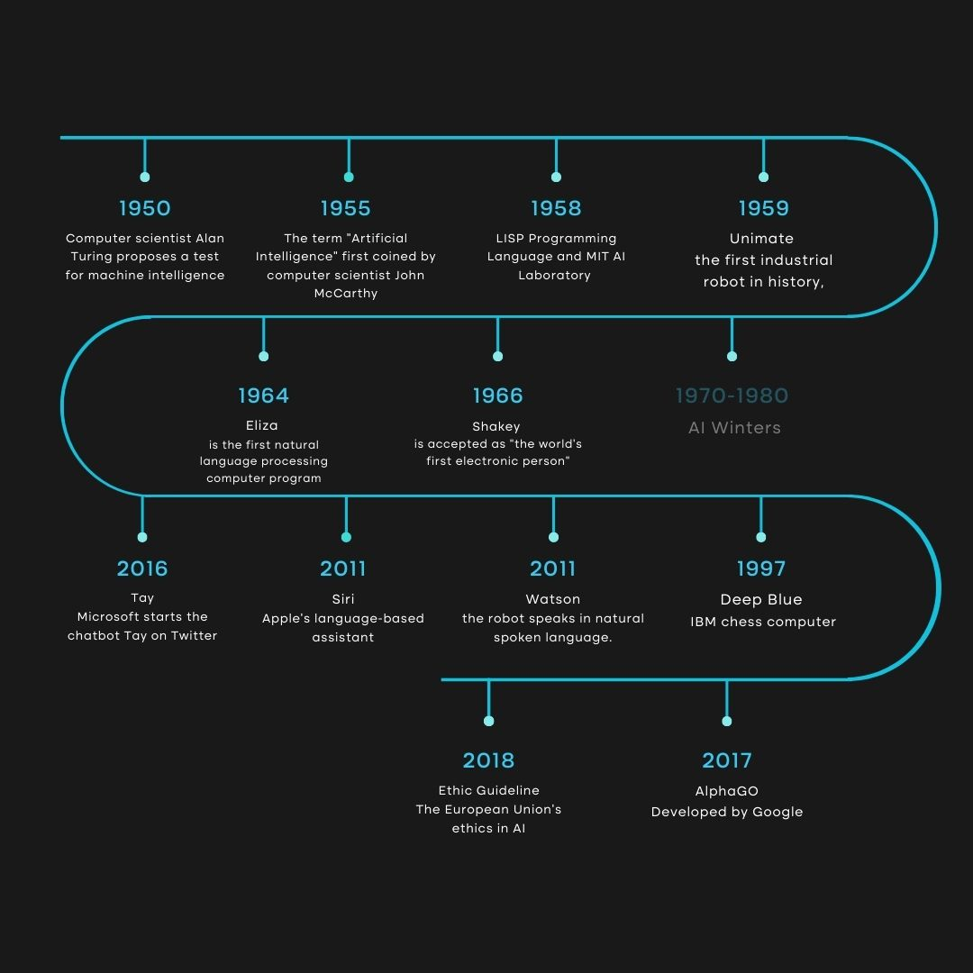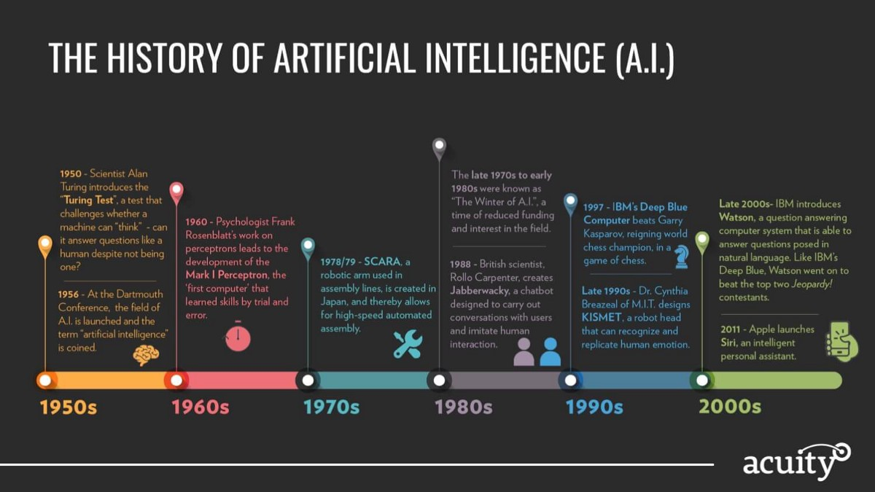

Moeilijkheden

https://www.google.com/url?sa=i&url=https%3A%2F%2Fwww.christipedia.nl%2Fwiki%2FKunstmatige_intelligentie&psig=AOvVaw26cRzR93P7aspu-LaXAzDR&ust=1668861883937000&source=images&cd=vfe&ved=0CA0QjRxqFwoTCKjJkJHht_sCFQAAAAAdAAAAABAH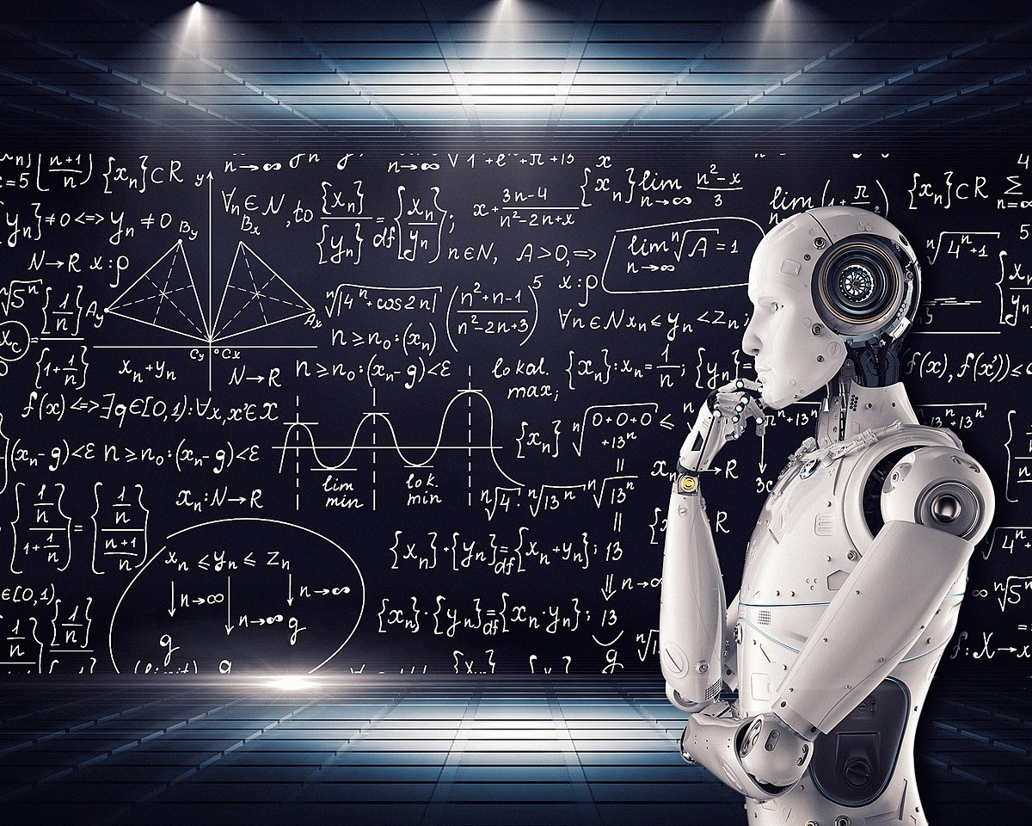

<https://www.google.com/url?sa=i&url=https%3A%2F%2Fairecht.nl%2Fkunstmatige-intelligentie&psig=AOvVaw26cRzR93P7aspu-LaXAzDR&ust=1668861883937000&source=images&cd=vfe&ved=0CA0QjRxqFwoTCKjJkJHht_sCFQAAAAAdAAAAABAL>

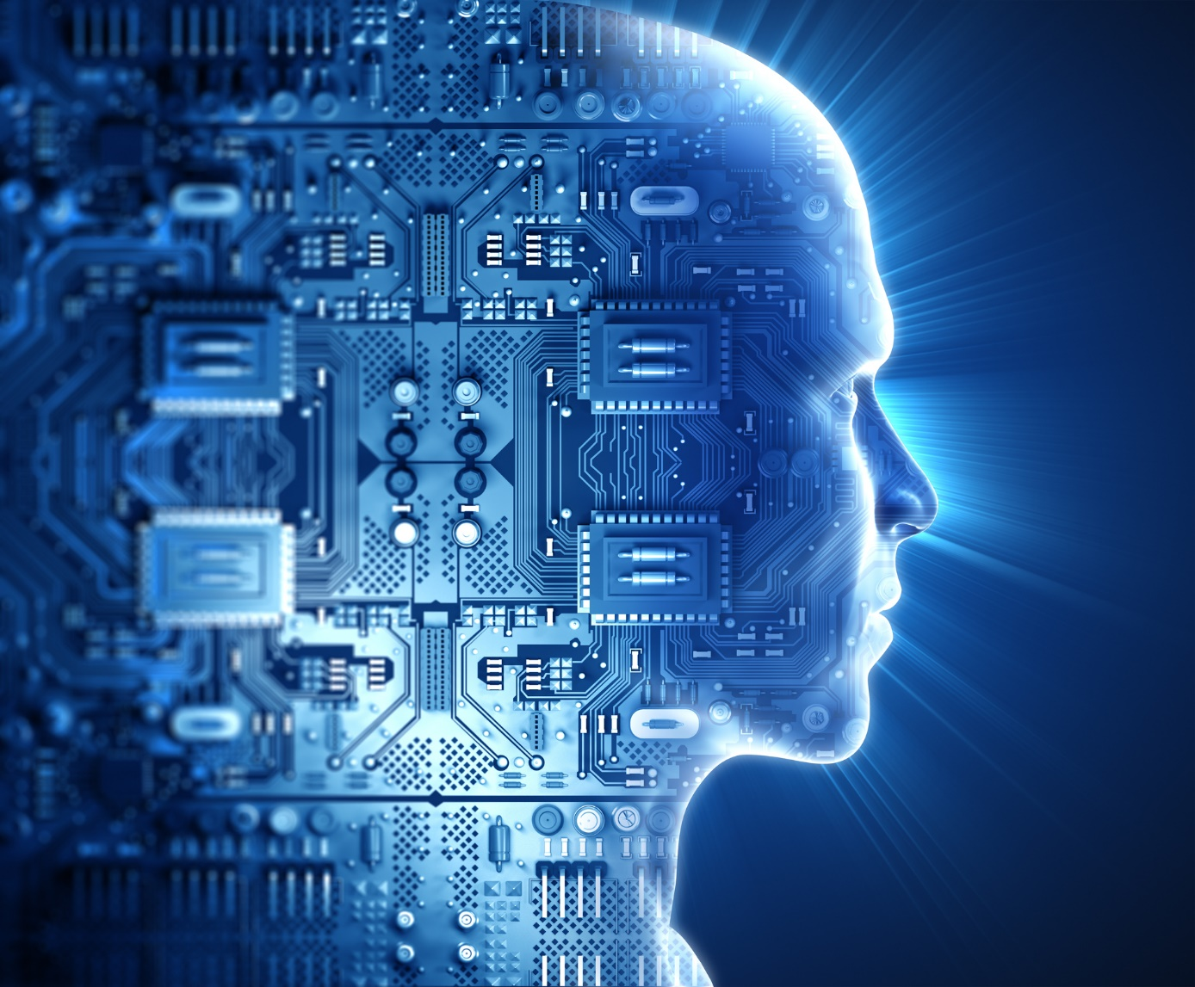

Doelen

[https://www.google.com/url?sa=i&url=https%3A%2F%2Fpoonam3958.wordpress.com%2Fgoals-of-ai%2F&psig=AOvVaw3G5QXMgrUulsK_2LHVOaaR&ust=1668862184775000&source=images&cd=vfe&ved=0CA0QjRxqFwoTCOjk8bfit_sCFQAAAAAdAAAAABAD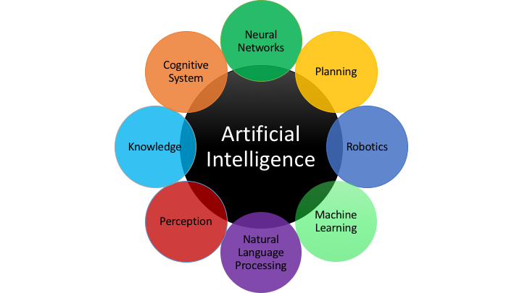](https://www.google.com/url?sa=i&url=https%3A%2F%2Fpoonam3958.wordpress.com%2Fgoals-of-ai%2F&psig=AOvVaw3G5QXMgrUulsK_2LHVOaaR&ust=1668862184775000&source=images&cd=vfe&ved=0CA0QjRxqFwoTCOjk8bfit_sCFQAAAAAdAAAAABAD#)

https://www.google.com/url?sa=i&url=https%3A%2F%2Fnareshit.com%2Fgoals-of-artificial-intelligence%2F&psig=AOvVaw3G5QXMgrUulsK_2LHVOaaR&ust=1668862184775000&source=images&cd=vfe&ved=0CA0QjRxqFwoTCOjk8bfit_sCFQAAAAAdAAAAABAI

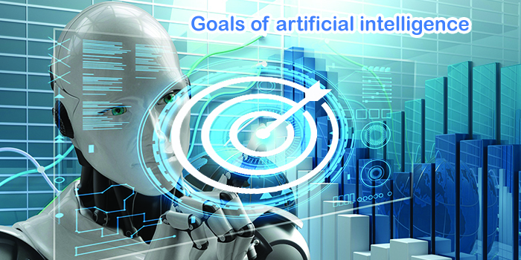

https://www.google.com/url?sa=i&url=https%3A%2F%2Fwww.mdpi.com%2F2071-1050%2F13%2F4%2F1738%2Fhtm&psig=AOvVaw3G5QXMgrUulsK_2LHVOaaR&ust=1668862184775000&source=images&cd=vfe&ved=0CA0QjRxqFwoTCOjk8bfit_sCFQAAAAAdAAAAABAq

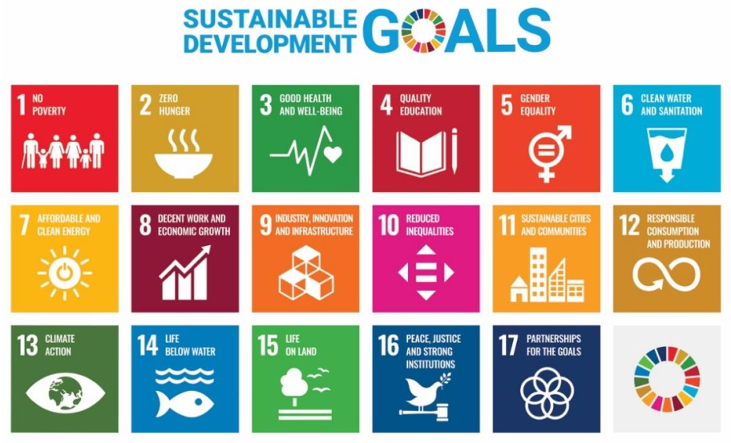

Toekomst

[**https://www.google.com/url?sa=i&url=https%3A%2F%2Fbuiltin.com%2Fartificial-intelligence%2Fartificial-intelligence-future&psig=AOvVaw37WueA1NBvPEJXOd1pHF6-&ust=1668862708919000&source=images&cd=vfe&ved=0CA0QjRxqFwoTCKCdp_Dkt_sCFQAAAAAdAAAAABAI**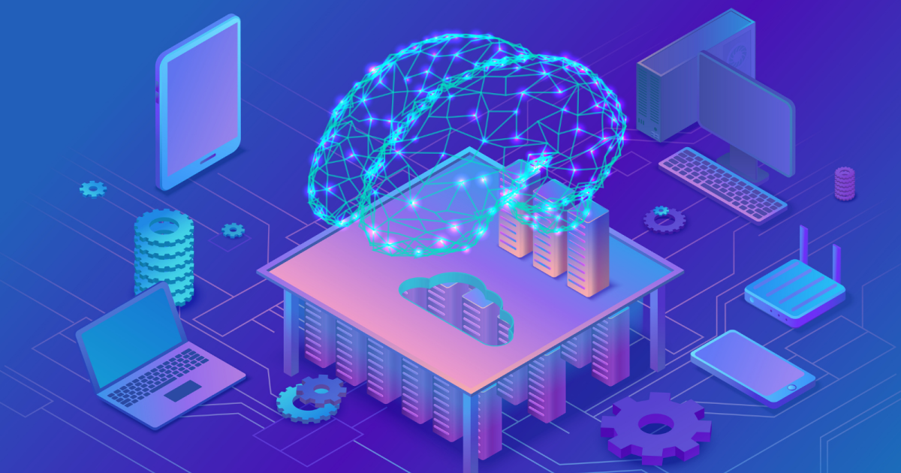](https://www.google.com/url?sa=i&url=https%3A%2F%2Fbuiltin.com%2Fartificial-intelligence%2Fartificial-intelligence-future&psig=AOvVaw37WueA1NBvPEJXOd1pHF6-&ust=1668862708919000&source=images&cd=vfe&ved=0CA0QjRxqFwoTCKCdp_Dkt_sCFQAAAAAdAAAAABAI#)

**https://www.google.com/url?sa=i&url=https%3A%2F%2Fwww.edureka.co%2Fblog%2Ffuture-of-ai%2F&psig=AOvVaw37WueA1NBvPEJXOd1pHF6-&ust=1668862708919000&source=images&cd=vfe&ved=0CA0QjRxqFwoTCKCdp_Dkt_** 

**https://www.google.com/url?sa=i&url=https%3A%2F%2Flitslink.com%2Fblog%2Fhow-artificial-intelligence-is-changing-the-world&psig=AOvVaw0dRtJE-NLDhZ82f2VhSkEq&ust=1668863023599000&source=images&cd=vfe&ved=0CA0QjRxqFwoTCJjJ8q_lt_sCFQAAAAAdAAAAABAE**